Case-Study-–-Multi-Tier-Architecture

You

Tasks To Be Performed in AWS Cloud

Web tier: Launch an instance in a public subnet and that instance should allow HTTP and SSH from the internet.

Application tier: Launch an instance in a private subnet of the web tier and it should allow only SSH from the public subnet of Web Tier-3.

DB tier: Launch an RDS MYSQL instance in a private subnet and it should allow connection on port 3306 only from the private subnet of Application Tier-4.

Setup a Route 53 hosted zone and direct traffic to the EC2 instance. You have been also asked to propose a solution so that:

Development team can test their code without having to involve the system admins and can invest their time in testing the code rather than provisioning, configuring and updating the resources needed to test the code.

Make sure when the development team deletes the stack, RDS DB instances should not be deleted.

Assignment Starts Here

Web tier:

Launch an EC2 instance in a public subnet with security group rules allowing HTTP (port 80) and SSH (port 22) access from the internet.

Make sure the security group associated with this instance allows incoming traffic on ports 80 and 22 from 0.0.0.0/0 (anywhere).

Now Launch EC in Private subnet

Application tier:

Launch another EC2 instance in a private subnet within the same VPC as the Web tier.

Configure the security group of this instance to allow SSH (port 22) traffic only from the private subnet of the Web tier.

VPC private subnet

Configure the security group of this instance to allow SSH (port 22) traffic only from the private subnet of the Web tier.

EC2 Instance Launch in Application Tier in private subnet

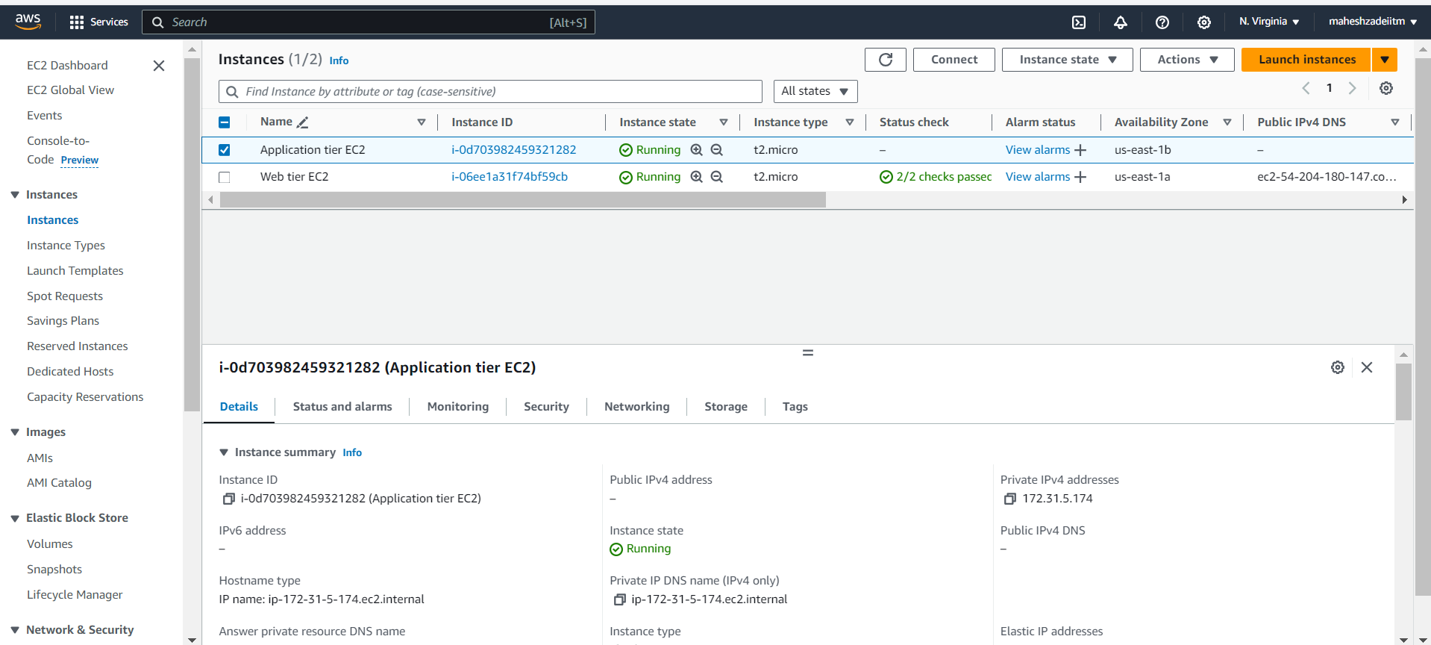

DB tier:

Launch an RDS MySQL instance in a private subnet within the VPC.

User name admin

Password : admin123456789

Set the security group of the RDS instance to allow incoming connections on port 3306 only from the private subnet of the Application tier.

Route 53 created

Create a Route 53 hosted zone for your domain.

Create an A record in the Route 53 hosted zone to direct traffic to the public IP address of the EC2 instance in the Web tier.

EC2 Instance Public IP copy

View details

Test record

For the proposed solutions

For the development team to test their code independently, you can set up an AWS CloudFormation template or an AWS Elastic Beanstalk environment that automates the provisioning of the required resources for testing. This way, the development team can deploy and test their code without involving system administrators.

Go to AWS Console and created a stack

Go to Application composer

Click on next

Review and create

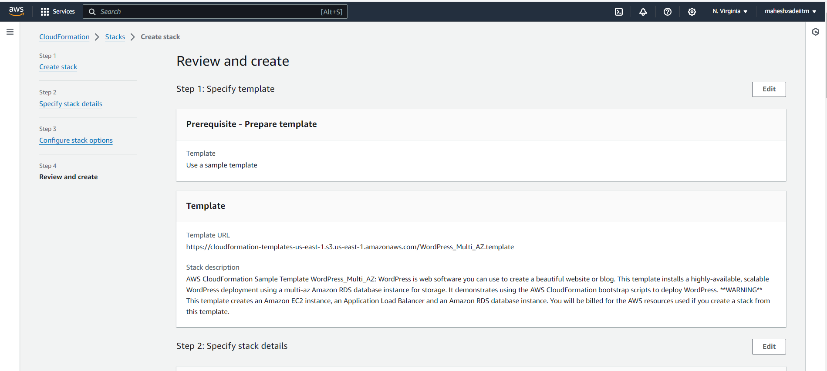

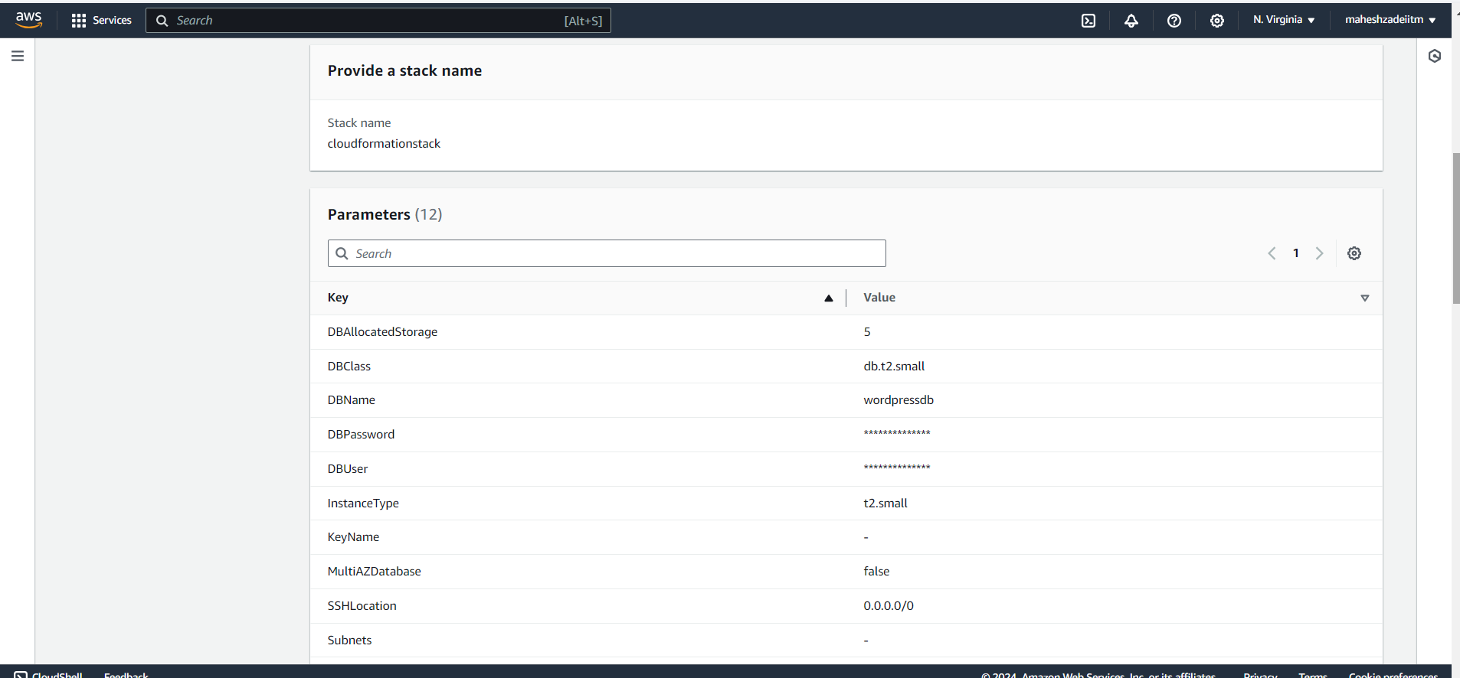

Status Available

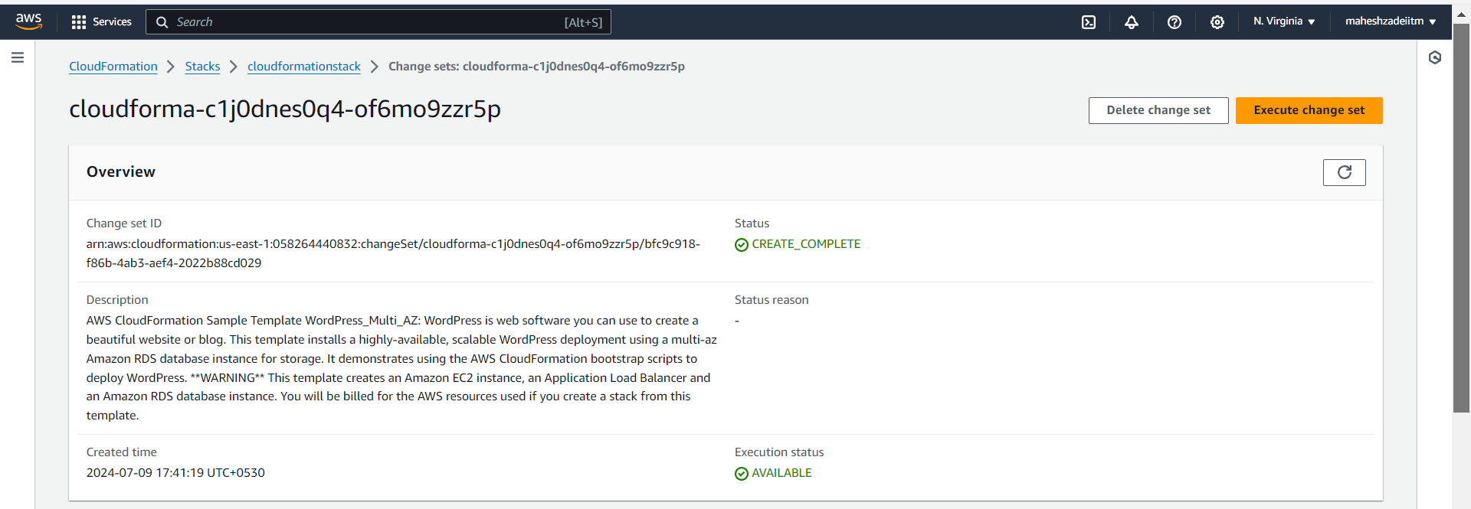

Stack crated

To ensure that RDS DB instances are not deleted when the development team deletes the stack, we can separate the RDS resources from the CloudFormation stack. By creating the RDS instances outside the CloudFormation stack or managing them separately, they will not be affected when the stack is deleted.

By following these steps and solutions, we can achieve the desired setup in AWS Cloud for our infrastructure requirements. Let me know if you need more detailed instructions on any of these steps.

Thanks